This file contains notes that explain how the data from the papers in this folder were interpreted for the purpose of the Data Archive process.

**A. Notes on Data Extraction as It Appears in Current Data Library**

1. The main paper in this folder is Callaway et al. (2012) "Wetland Sediment Accumulation at Corte Madera Marsh and Muzzi Marsh" which reports soil carbon stocks and soil carbon accretion rates. Classification of salinity regimes were drawn from Table 1 (below).

Callaway 2012a: Table 1.

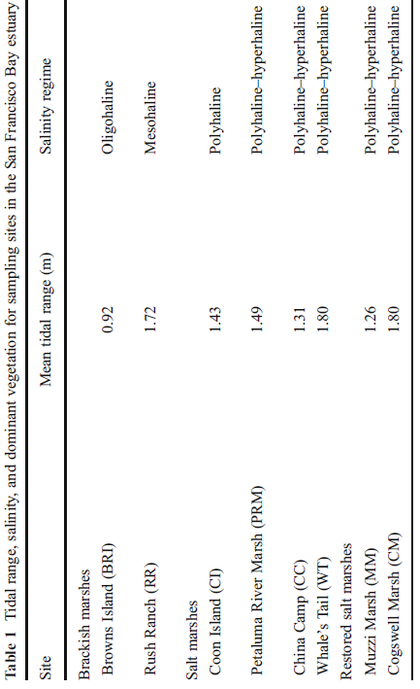

2. The paper does not report carbon density directly. We calculated carbon density from Table 2, which reported percent organic matter and bulk density, but not carbon concentration. They provided data for three elevations at eight sites, for a total of 24 unique observations. To calculate carbon density, their data were entered into a spreadsheet, then processed with SAS code to calculate carbon density. The calculation steps were as follows:

a. Convert organic matter (OM) to organic carbon units.

We used the following equation developed by James Holmquist (in review):

SoilCC=0.074*(OM/100)*(OM/100) + 0.421*(OM/100) - 0.0080, where

SoilCC = C concentration in units of grams C per grams soil

OM = organic matter concentration in units of grams OM per grams soil

b. Convert soil carbon concentration (SoilCC) to carbon density.

SC=SoilCC*BD, where

SC=Soil carbon density in units of grams carbon per cubic centimeter (g/cm3)

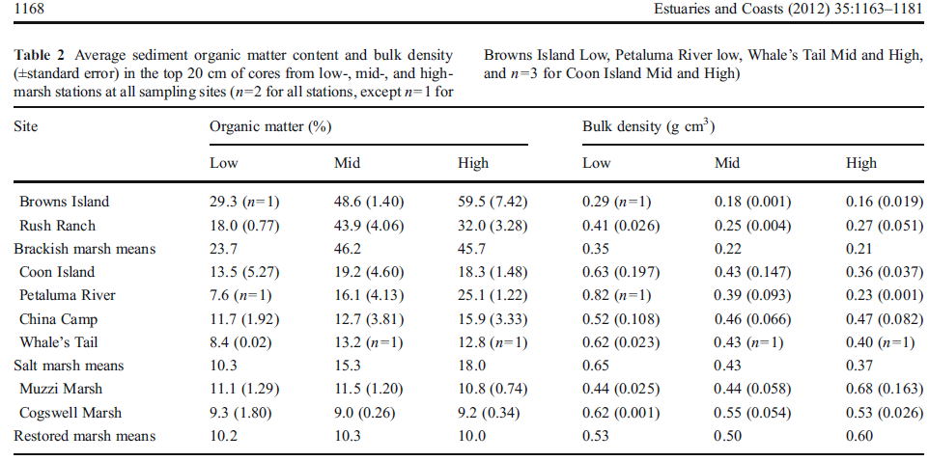

3. Soil carbon accretion rate (SCrate) was calculated from the average of 137Cs and 210Pb C rates in table 3. (The method Blanca used was to average 137Cs and 210Pb rates in each site and make sure to differentiate between low-mid-high and brackish vs saline). However, Pat decide to enter all the original data for 137Cs and 210Pb in the spreadsheet.

Table 3.

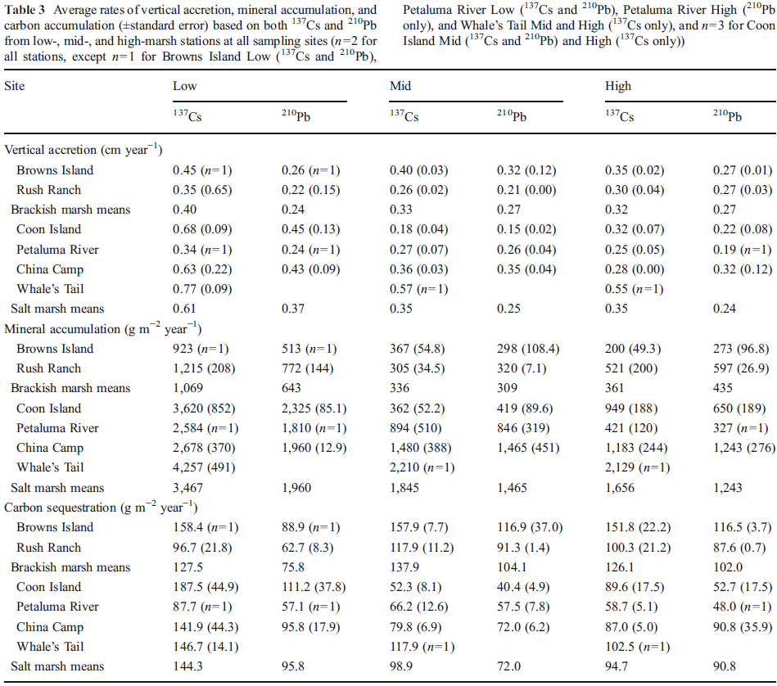

**B. History of Calculation Refinements**

1. This section explains changes or refinements made after the 2016 figures reported by the EPA for coastal wetlands as part of the US carbon accounting to the IPCC. Note that information quoted directly from Blanca in italics. Clarifications added by Meng and Pat in normal font below.

(i) Meng could not find the original data from the paper, but located another paper from Callaway (the first author) published in the same year. He also was not sure of the unit for soil C was g C/cm2. He asked Blanca to double check these.

***Blanca’s Response Part 1:*** *the data in the "salt marsh soil C" tab seems to be from the Estuaries and Coasts paper. They used information in table 1 and data in table 2. The results of gC/*cc [i.e. as it appeared in Blanca’s spreadsheet, not in this paper] *do not come out exactly the same as would come out if you assume OM = 50% C, maybe because they* [i.e. Tiffany Troxler-Gann or others who originally compiled data for including tidal wetlands in the IPCC process] *assumed OM = 58% C like some people do (van Bemmelen factor), or other %. For consistency, we should do 50%... or recalculate ALL the numbers in the entire dataset with the van Bemmelen factor... up to you. Both ways are fine, we just have to explain in the paper what assumption we used.*

**Mengs’s Response to Blanca Part 1:** The two paper being discussed (Callaway et al. 2012a and 2012b) report data from different sites. In the original IPCC accounting, data was apparently taken from both papers for making certain calculations (still a bit unclear how). We decided the two papers should be treated separately because they are different sites. This means that much of the discussion by Blanca above will not be relevant to the revised version of these data because we will not attempt to combine the data.

***Blanca’s Response Part 2:*** *This paper has useful data for "salt marsh rate" tab that was not included in the dataset. Please add it - use info in table 1 for site classification and C rates in table 3 (average 137Cs and 210Pb rates in each site and make sure to differentiate between low-mid-high and brackish vs saline).*

*I think the data we have already in the "salt marsh rate" tab is from the other Callaway paper we already had. Corte Madera site is natural and Muzzi is restored. The rates in the dataset must be some kind of combination of the 3 elevations and 2 transects (or maybe only one elevation). Both transects and elevations are very close to each other, so they could have been averaged in to one for each wetland. I don't know. We should report all of them individually, not averaged. Take the soil accretion rate from this sentence in p.7: "annual rates of accretion at Corte Madera Marsh were 0.30, 0.21, and 0.17 cm/yr for low, mid, and high stations, respectively. Rates at Muzzi Marsh were 0.80, 0.80, and 0.39 cm/yr for low, mid, and high stations, respectively". Table 4 gives you %OM; do the average for all depths in each site and convert to %C. DO the same for BD (table 5). With %C, BD, and cm/y you can calculate gC/m2/y as we talked about.*

*These 2 wetlands are not included in the "salt marsh soil" tab; you can include them too.*

*cite these sources as Callaway et al 2012a, and Callaway et al 2012b.*

**Mengs’s Response to Blanca Part 2:** The second paper reporting on the Corte Madera and Muzzi sites (Callaway et al. 2012b) was put into a separate folder, and data was kept separate for the high, mid and low elevations as Blanca suggested (and per our guidelines).